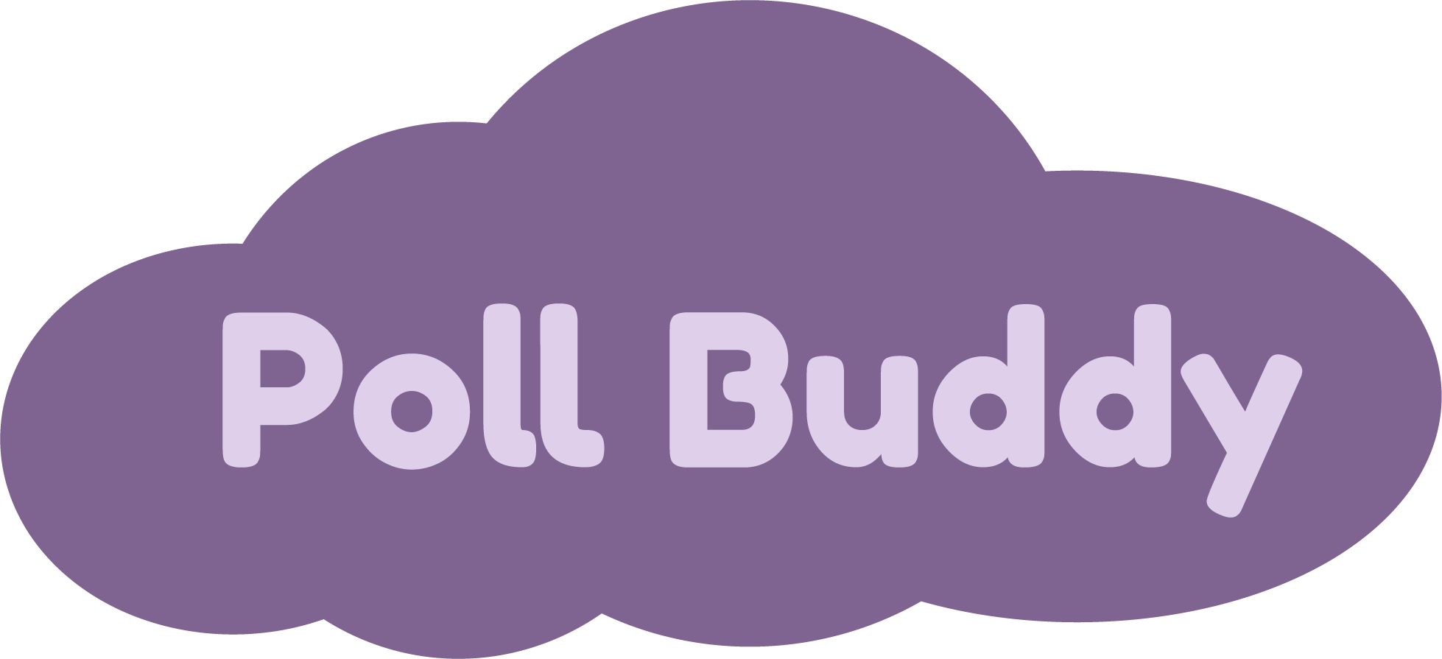

**Introduction:**

* Many professors use iClickers to ask questions or polls to their students.
* However, iClickers are expensive, bulky, outdated, easy to forget, difficult to integrate with other programs, and only professors can track answers.
* Therefore, we decided to create a website that has similar, yet improved functionality of iClickers, called **Poll Buddy**.
* Poll Buddy is a website that professors can use to interact with students during class. Professors will log in to their Poll Buddy account and will be able to create questions. Students will be able to log in to their accounts where they will be able to see the answer options and will be able to get Poll Buddy points for answering them. Both professors and students will be able to see question results and other statistics. Students will be able to view their Poll Buddy points at any time.

**Languages:** *Frontend*: HTML, CSS, JavaScript, React

*Backend*: NodeJS, MongoDB, Express, Docker, GitHub Actions

**Current Status:**

* Most frontend pages have been designed and are visually implemented in code.
* The site’s backend, responsible for handling tasks like application logic and database interactions, has a large portion of functionality complete.
* There is still a fair bit of work to do on the frontend (further visual fixes, backend integration) before Poll Buddy can enter trials for deployment and in-classroom use.

**Development Milestones:**

* By the middle of the 2021 Summer Semester, the team aims to have evolved Poll Buddy to a state where it can begin RCOS trials.
* The development milestones outlined below detail some of the steps to be taken to reach this state. The project will still need to be worked on in future semesters to refine and tailor it to the needs and feedback from students and professors.
* End of June:
  + Proposal
  + Get everyone up to speed on the repo, tools, etc.
  + More documentation in code and wiki
  + Automatic emailing system
  + Continued work on client-server communication and page functionality
  + Assumed frontend and backend bug fixes during integration
* End of July:
  + Continued work on client-server communication and page functionality
  + Assumed frontend and backend bug fixes during integration
  + Code and page cleanups
  + Early RCOS testing
  + Dev site controller build out
* End of August/Semester:
  + Logging/reporting work
  + Bug fixes
  + Continued testing and fixes
  + ~~Take over~~ Change the world!

**Team Members:**

Poll Buddy **Hunter Harris** [**harrih3@rpi.edu**](mailto:harrih3@rpi.edu) **(PM)**

Poll Buddy **Brian Lin** [**linb4@rpi.edu**](mailto:linb4@rpi.edu)

Poll Buddy **Jacob Sandling** [**sandlj@rpi.edu**](mailto:sandlj@rpi.edu)

Poll Buddy **Zhenyuan Gong** [**gongz3@rpi.edu**](mailto:sandlj@rpi.edu)

Poll Buddy **Dingheng Yan** [**yand@rpi.edu**](mailto:yand@rpi.edu)

Poll Buddy **Justin Kwong** [**kwongj@rpi.edu**](mailto:kwongj@rpi.edu)

Poll Buddy **Bruno Spinelli** [**spineb2@rpi.edu**](mailto:spineb2@rpi.edu)